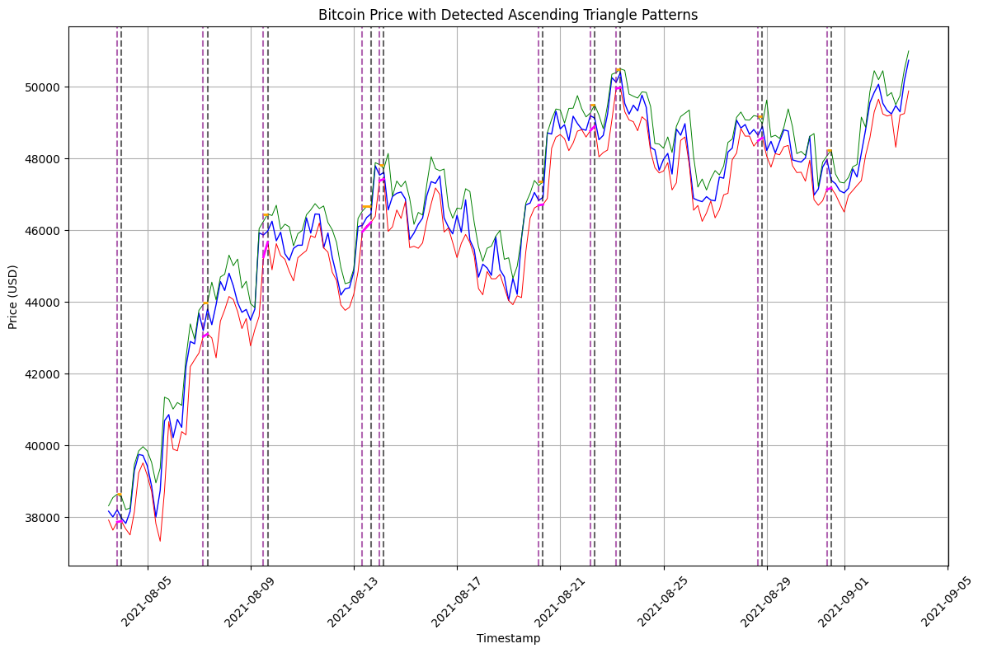**One month data – 10 Ascending Triangle patterns**